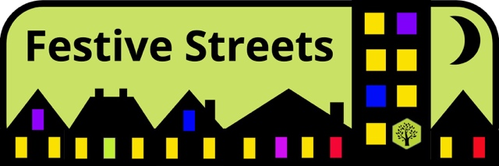
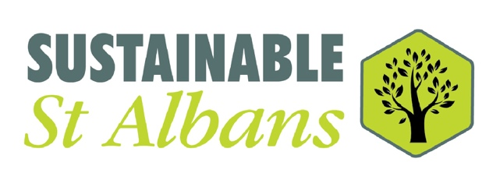
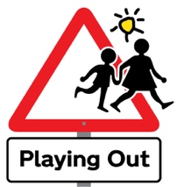
Festive Streets – a new community project

We’re very excited to tell you about our new scheme in St Albans District called Festive Streets. Festive Streets has been started by the team from Playing Out St Albans District, which is project run by the environmental charity, Sustainable St Albans.

“Decorate the windows on your street”

The project encourages neighbours in St Albans, Harpenden and the villages to decorate the windows on their streets during the winter Festive Season, enabling them to celebrate as a community in a contact-free way and bring cheer to their neighbourhood.

Festive classrooms, community buildings, residential homes or office blocks too

The Festive Street concept could equally be applied to school classroom windows, residential homes, an office block, a community or faith building or a parade of shops.

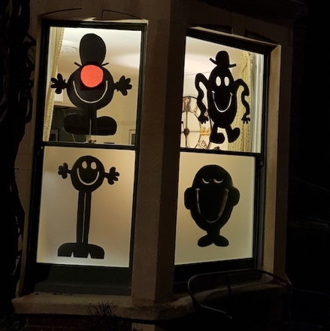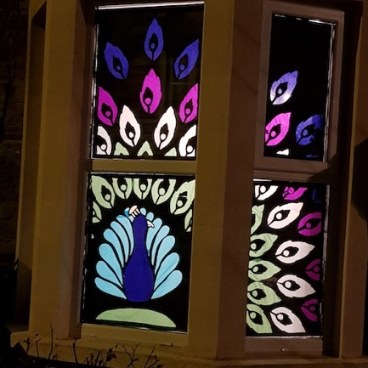

Co-ordinate with neighbours

In its simplest form, neighbours volunteer to decorate a street-facing window of their home and co-ordinate with each other to agree a timetable and a theme.

Involve all the neighbours

All the neighbours in a street are invited to join in with Festive Streets - whether they choose to decorate a window or simply enjoy the displays. This is a key feature of the project – it is welcoming to all and builds community at the street level.

Keep it simple or go to town

The project is run at street level and neighbours can decide for themselves whether to keep it simple or go the full hog - perhaps raising money for charity or choosing a more ambitious theme.

Keeping it sustainable and safe

Residents are encouraged to use sustainable, recycled materials wherever possible and minimise energy usage, particularly on lights. All activities must be Covid-safe.

Sign up for free information pack

You are invited to sign up for a free information pack via our webpage at https://sustainablestalbans.org/playingout.

